Digital Signal Processing Lab

Lab sheet 9

Name: KVNG Vikram

Sc code: sc15b148

1) Visualization of the bilinear transform: The bilinear transform is a map between the s-plane and the z-plane and is defined as z = (1+sT/2)/(1-sT=2) . The inverse map is defined as s = 2/T\*(1-(1/z))/(1+(1/z)) . In this task you will visualize how an area in the s plane is mapped to z-plane and vice-versa.

(a) Select N X M points si,j uniformly in any rectangular region that you wish in the s-plane. (Hint: you can use meshgrid for this purpose). On the z-plane indicate where these points are mapped to under the bilinear transform.

(b) Similarly select N M points zi;j uniformly in any rectangular region that you wish in the z-plane. (Hint: you can use meshgrid for this purpose). On the s-plane indicate where these points are mapped to under the bilinear transform.

(c) Verify (using a sufficiently dense set of points) whether the j axis is mapped to the unit circle under the bilinear transform.

Ans.

Code:

a) f=-10:.1:10;

for x=1:length(f)

for y=1:length(f)

z(x,y)=f(x)+j\*f(y);

end

end

b) f=-10:.1:10;

for x=1:length(f)

for y=1:length(f)

s(x,y)=f(x)+j\*f(y);

end

end

c) T = input('Enter the value of T in Bilinear transform equation ')

%z = (1 + T\*(s./2))./(1- T\*(s./2));

w = [ -pi : 0.001 : pi ];

for W = 1 : length(w)

z(W) = exp(j.\*w(W));

end

s = (2/T)\*(1 -(1./z))./(1+(1./z));

Inference:

The above numbers are very close to the jΩ axis, this deviation from the original is obtained because of the number of points taken from z. If the no. of sample points for z is increased from the equation: z = exp(jw) by increasing the samples of w then we obtain a more closer line to the jΩ axis.

Q2) Filter design using least squares inverse design: Suppose the desired frequency response Hd(ej!) can be realized by the causal system with the following z-transform,

Hd(z) =(1 + z-1)/(1-0.5z-1)

Suppose we approximate Hd(z) using a H(z) of the form

b0/(1 - a1z-1 - a2z-2 )

Using least squares inverse design, obtain the values of b0, a1 and a2. We note that in least squares inverse design, a set of linear equations have to be written down which constrain the values of b0; a1 and a2. Explore the effect of the number of linear equations that you have on your answer

Ans.

The equations were solved and the value of the output was calculated out to be

a1 = -1.5, a2 =1.5, b0=

Q3) Filter design using Butterworth analog filter design and impulse invariance: Suppose we have the following desired requirements Hd(ej!) on the magnitude of digital filter:

(a) Passband edge = 0:2pi

(b) Stopband edge (starting freq) = 0:4pi

(c) Magnitude gain in passband to be [1, 1 –dp], where dp = 0:05

(d) Magnitude gain in stopband to be 2 [0; ds], where ds = 0:001

Note that no constraints are being put on the phase response of the filter here. In the design of the filter, explore how you would use the \buttord" inbuilt function in Matlab.

(a) Assuming that there is no aliasing and that Hd(ej!) has been obtained from sampling of an analog signal ha(t) uniformly at rate 1/T , what is Ha(jomega) (the CTFT of ha(t))?.

(b) We note that Ha(jomega) can be interpreted as the specification for the design of an analog filter. Obtain a Butterworth filter that is a good approximation to Ha(jomega).

(c) Write down the location of the poles of the analog Butterworth filter Ha(s)?

(d) Under the impulse invariance condition, where are these poles mapped to in the z-plane. Write down the locations of the poles.

(e) Plot the frequency response of the filter that you have obtained.

Exploration:

(a) Does the design depend on the actual value of T? Is there any change in the frequency response of the realized digital filter if you use different values of T?

(b) Repeat the design process but by not compensating for aliasing in the stopband attenuation. How much is stopband attenuation in the final design? Does it meet the given requirements on Hd(ej!)?

(c) Using internet resources or Matlab help, find out what the inbuilt function “butter"does. How will you use “butter" for the design problem above?

(d) Using internet resources or Matlab help, find out what the inbuilt function “filter" does. Suppose x[n] = 2cos(0.1\*pi\*n)+5cos(0.6\*pi\*n) for n = f0; : : : ; 499g. Simulate what happens when the filter that you have designed above is used to filter x[n] in order to obtain y[n].

Plot y[n] as well as its DTFT.

Ans.

Code:

T = input('Enter the sampling period: ')

[ N , Wn ] = buttord(0.2\*pi/T,0.4\*pi/T,(-20\*log10(1-0.05)),60,'s');

[B,A] = butter(N,Wn,'s');

[r,p,k] = residue(B,A);

[b, a] = residuez(r,exp(p\*T),k);

freqz(b,a);

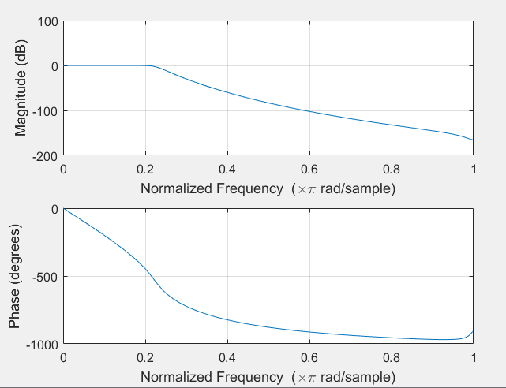Output: